Consultation Services
As of April 2021 patient access to is via the digital system on our website found on the right hand side of the home page as below.
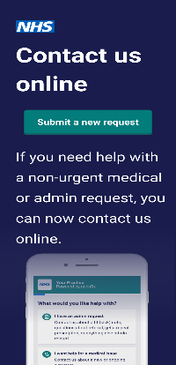
From here you will be signposted to the most appropriate service to help with your problem, this will not always be a Doctor. If you do need to consult with a Doctor your consultation will in the first instance be via text unless the Doctor feels they need to telephone you or book a face to face consultation for clinical reasons. Please be reassured that this is a confidential system and a national initiative that was planned before the COVID Pandemic to provide varied and efficient methods of accessing help for medical problems, to assist with as many patients being able to be helped as possible. To get the best out of the system please include as much information as you can.
Prescriptions are only available via this route or via our dedicated dispensing phone line
Tel: 01768 361530
---------------------------------------
Test Results / Patient Notes / Medication Record / Appointment Booking
It is possible to access your results, limited patient record, medication history and book appointments online please see the form in the link below which you must complete and return to us, or alternatively you can collect one from the Practice.
We would encourage all patients who are able, to sign up for online access service as it reduces the number of calls our Patient Support Team deal with regarding routine matters you can manage yourself leaving our phone line accessible for emergencies
There is information on our website under the ‘Self Referral Information’ tab found on the left hand side of our Home Page, from where you can refer yourself for various problems including: Musculoskeletal Physiotherapy, Podiatry-Foot & Ankle, Unity Alcohol & Drug Recovery Service, First Steps Counselling and the E-School nurse.
If you are genuinely unable to use our digital platform please telephone the surgery as you would have previously.
Paula Breen
Practice Manager

